100 grams Super premium Red Nest AAA

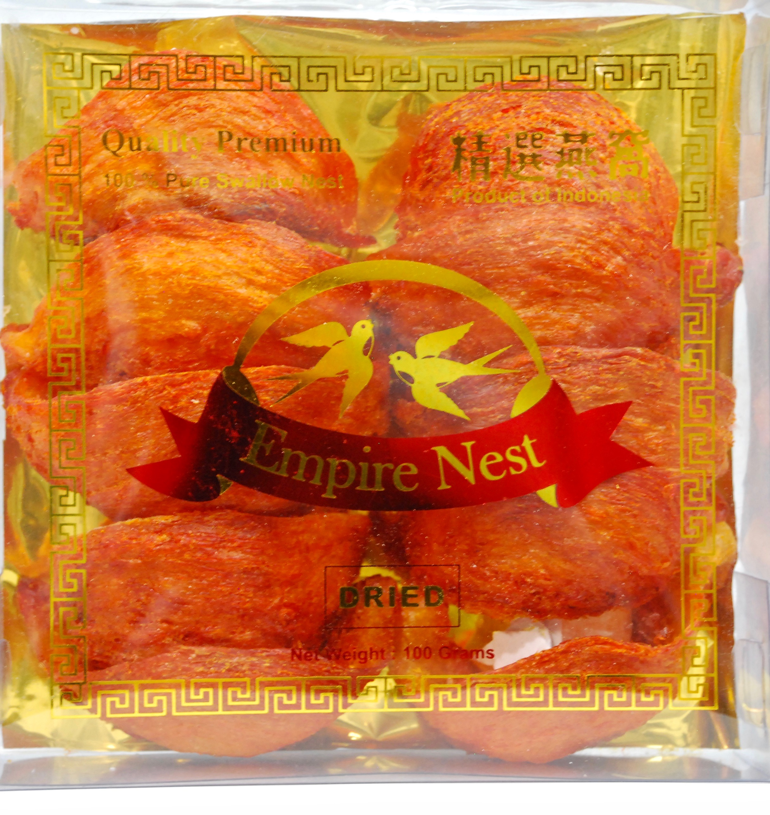

250 grams Super premium Red Nest AAA

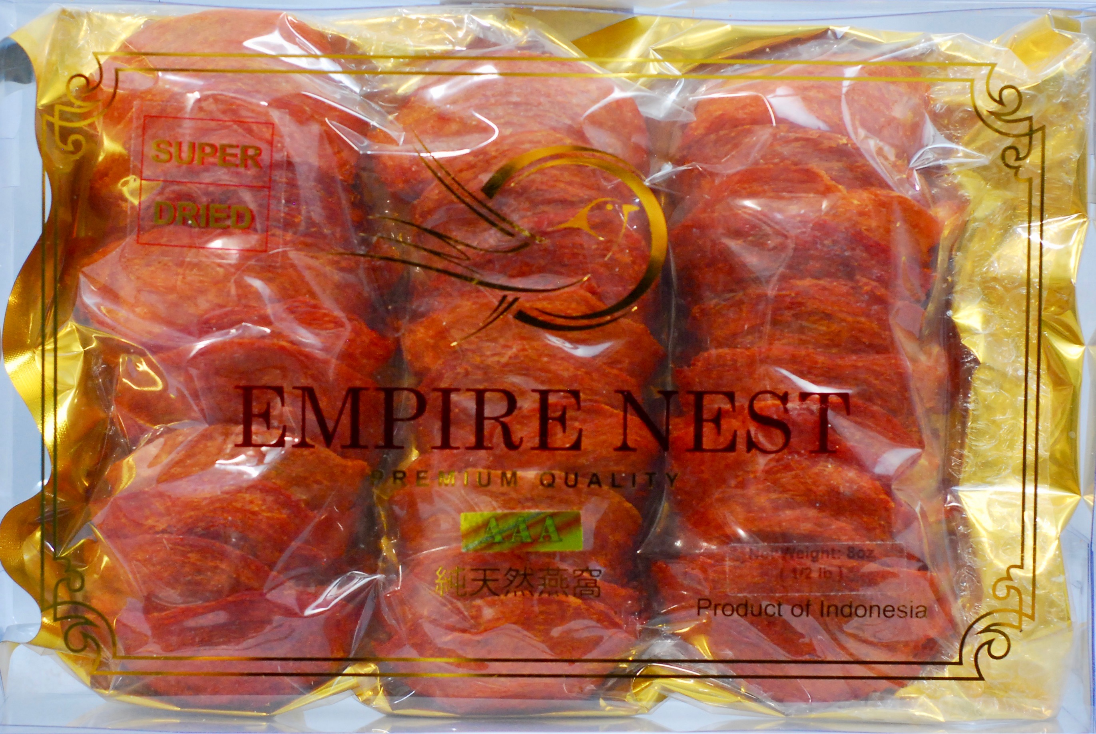

250 grams Super premium Red Nest AAAA

